**Aim :- Implementation of Data partitioning through Range and List partitioning.**

**Distributed Databases: -**

A distributed database is basically a database that is not limited to one system, it is spread over different sites, i.e, on multiple computers or over a network of computers. A distributed database system is located on various sited that don’t share physical components. This maybe required when a particular database needs to be accessed by various users globally. It needs to be managed such that for the users it looks like one single database.

**Types:**

**1. Homogeneous Database:** In a homogeneous database, all different sites store database identically. The operating system, database management system and the data structures used – all are same at all sites. Hence, they’re easy to manage.

**2. Heterogeneous Database:** In a heterogeneous distributed database, different sites can use different schema and software that can lead to problems in query processing and transactions. Also, a particular site might be completely unaware of the other sites. Different computers may use a different operating system, different database application. They may even use different data models for the database. Hence, translations are required for different sites to communicate.

**Data Partitioning: -** Partitioning is the database process where very large tables are divided into multiple smaller parts. By splitting a large table into smaller, individual tables, queries that access only a fraction of the data can run faster because there is less data to scan. The main of goal of partitioning is to aid in maintenance of large tables and to reduce the overall response time to read and load data for particular SQL operations.

**Range Partitioning: -** Range partitioning is a type of relational database partitioning wherein the partition is based on a predefined range for a specific data field such as uniquely numbered IDs, dates or simple values like currency. A partitioning key column is assigned with a specific range, and when a data entry fits this range, it is assigned to this partition; otherwise it is placed in another partition where it fits.

**List Partitioning: -** Unlike range partitioning, with list partitioning, there is no apparent sense of order between partitions. You can also specify a default partition into which rows that do not map to any other partition are mapped.

1. **Range Partitioning:**

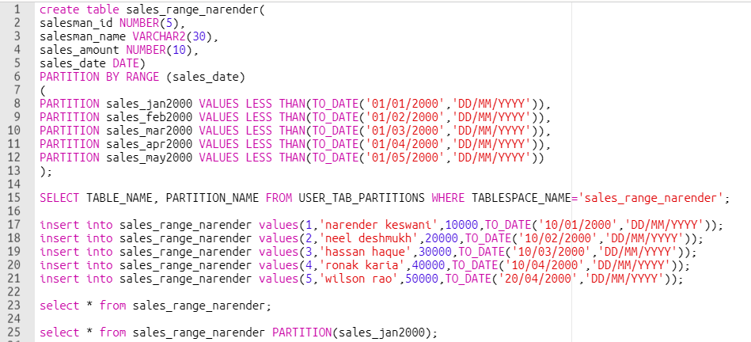

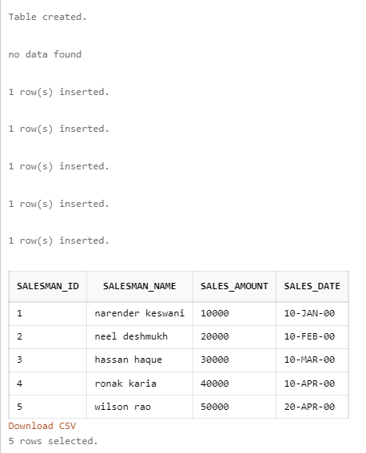

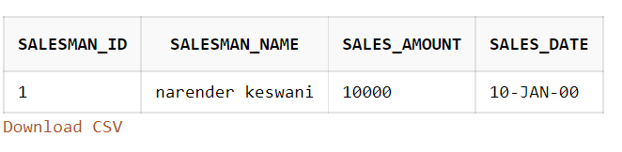

1. **List Partitioning:**

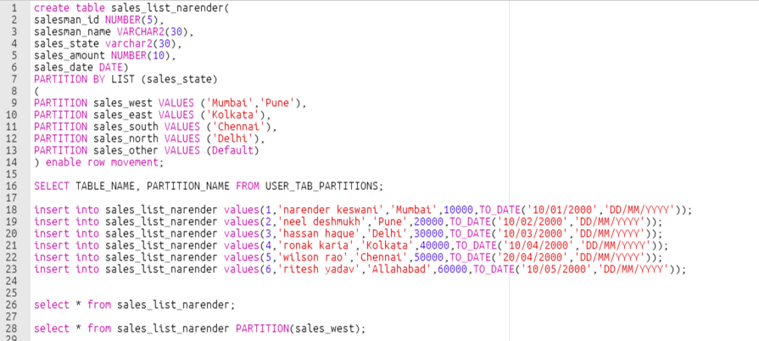

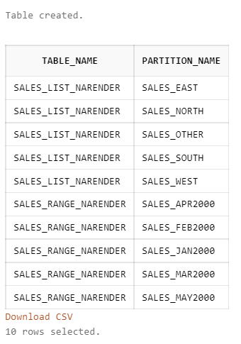

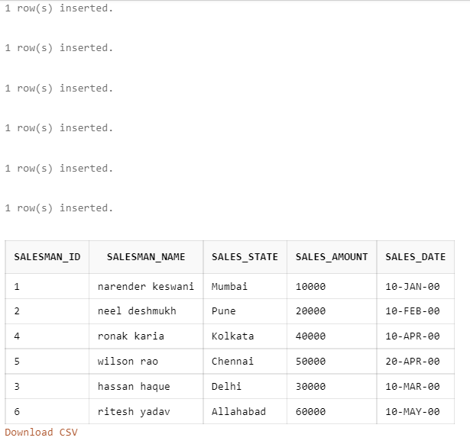

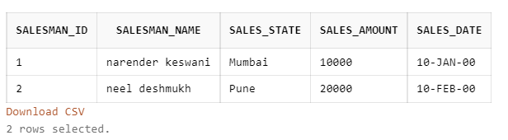

**CONCLUSION:**

I have learned the basics of distributed database management system with techniques such as: range and list in oracle.

**SOURCE CODE:**

create table sales_range_narender(

salesman_id NUMBER(5),

salesman_name VARCHAR2(30),

sales_amount NUMBER(10),

sales_date DATE)

PARTITION BY RANGE (sales_date)

(

PARTITION sales_jan2000 VALUES LESS THAN(TO_DATE('01/01/2000','DD/MM/YYYY')),

PARTITION sales_feb2000 VALUES LESS THAN(TO_DATE('01/02/2000','DD/MM/YYYY')),

PARTITION sales_mar2000 VALUES LESS THAN(TO_DATE('01/03/2000','DD/MM/YYYY')),

PARTITION sales_apr2000 VALUES LESS THAN(TO_DATE('01/04/2000','DD/MM/YYYY')),

PARTITION sales_may2000 VALUES LESS THAN(TO_DATE('01/05/2000','DD/MM/YYYY'))

);

SELECT TABLE_NAME, PARTITION_NAME FROM USER_TAB_PARTITIONS WHERE TABLESPACE_NAME='sales_range_narender';

insert into sales_range_narender values(1,'narender keswani',10000,TO_DATE('10/01/2000','DD/MM/YYYY'));

insert into sales_range_narender values(2,'neel deshmukh',20000,TO_DATE('10/02/2000','DD/MM/YYYY'));

insert into sales_range_narender values(3,'hassan haque',30000,TO_DATE('10/03/2000','DD/MM/YYYY'));

insert into sales_range_narender values(4,'ronak karia',40000,TO_DATE('10/04/2000','DD/MM/YYYY'));

insert into sales_range_narender values(5,'wilson rao',50000,TO_DATE('20/04/2000','DD/MM/YYYY'));

select * from sales_range_narender;

select * from sales_range_narender PARTITION(sales_feb2000);

------------------------------------------------------------------------------------------------------------------

create table sales_list_narender(

salesman_id NUMBER(5),

salesman_name VARCHAR2(30),

sales_state varchar2(30),

sales_amount NUMBER(10),

sales_date DATE)

PARTITION BY LIST (sales_state)

(

PARTITION sales_west VALUES ('Mumbai','Pune'),

PARTITION sales_east VALUES ('Kolkata'),

PARTITION sales_south VALUES ('Chennai'),

PARTITION sales_north VALUES ('Delhi'),

PARTITION sales_other VALUES (Default)

) enable row movement;

SELECT TABLE_NAME, PARTITION_NAME FROM USER_TAB_PARTITIONS;

insert into sales_list_narender values(1,'narender keswani','Mumbai',10000,TO_DATE('10/01/2000','DD/MM/YYYY'));

insert into sales_list_narender values(2,'neel deshmukh','Pune',20000,TO_DATE('10/02/2000','DD/MM/YYYY'));

insert into sales_list_narender values(3,'hassan haque','Delhi',30000,TO_DATE('10/03/2000','DD/MM/YYYY'));

insert into sales_list_narender values(4,'ronak karia','Kolkata',40000,TO_DATE('10/04/2000','DD/MM/YYYY'));

insert into sales_list_narender values(5,'wilson rao','Chennai',50000,TO_DATE('20/04/2000','DD/MM/YYYY'));

insert into sales_list_narender values(6,'ritesh yadav','Allahabad',60000,TO_DATE('10/05/2000','DD/MM/YYYY'));

select * from sales_list_narender;

select * from sales_list_narender PARTITION(sales_west);